Name

Mathematics Stage 4
Rounding Decimals

Book 1 | Rounding Decimals  Terminating and Recurring Decimals | Version: 260301  Feedback:  https://MrDingMaths.com
Contents
Syllabus Content 2
Learning Intention 8

Syllabus Content
MA4-FRC-C-01 represents and operates with fractions, decimals and percentages to solve problems
Round decimals to a specified degree of accuracy using approximations
- Round decimals to a given number of decimal places
- Apply the notation ≈ as a symbol of numerical approximation
- Reason why an approximation may be more appropriate than an exact answer and vice versa
Identify terminating and recurring decimals
- Use either dot or vinculum notation for recurring (repeating) decimals
- Classify decimals as recurring or terminating

Rounding Decimals using a Number Line

- Rounding
Rounding means to make a number simpler while keeping its value close to what it was.
When rounding, we go to the nearest given place value.
E.g., when rounding 1.6 to the nearest whole, round to 2 as it is closer to 2.
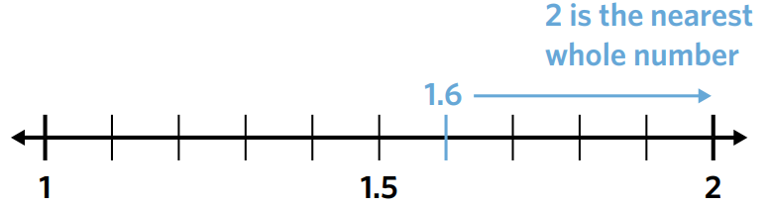

- Round decimals using a number line
- Round 9.9 to the nearest whole | 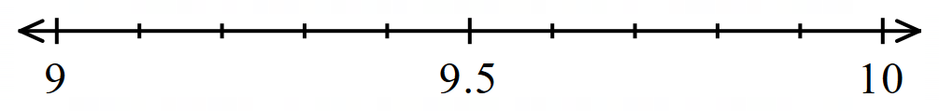  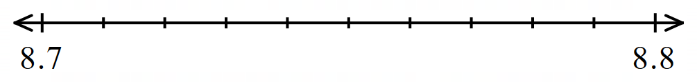  - Round 8.74 to the nearest tenth.
- Round 14.48 to the nearest tenth. | 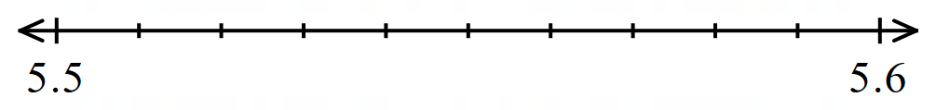  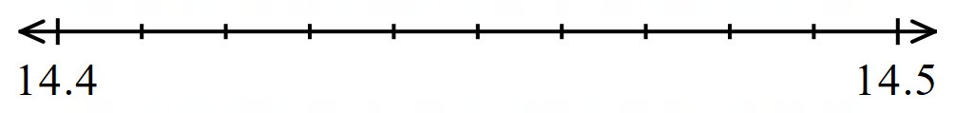  - Round 5.55 to the nearest tenth.
- Round 2.851 to the nearest hundredth. | 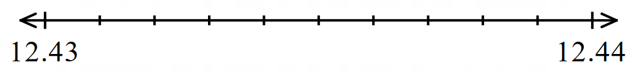  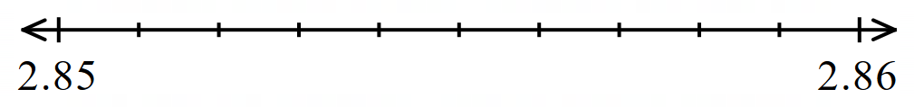  - Round 12.436 to the nearest hundredth.

- Key Ideas
- Rounding makes a number ……………… while keeping its value close to what it was.
- We round ………… when the number is halfway or more to the next place value.
- We round down when a number is ……… than halfway to the next place value.

Foundation
- Round these decimals to the nearest whole using a number line.
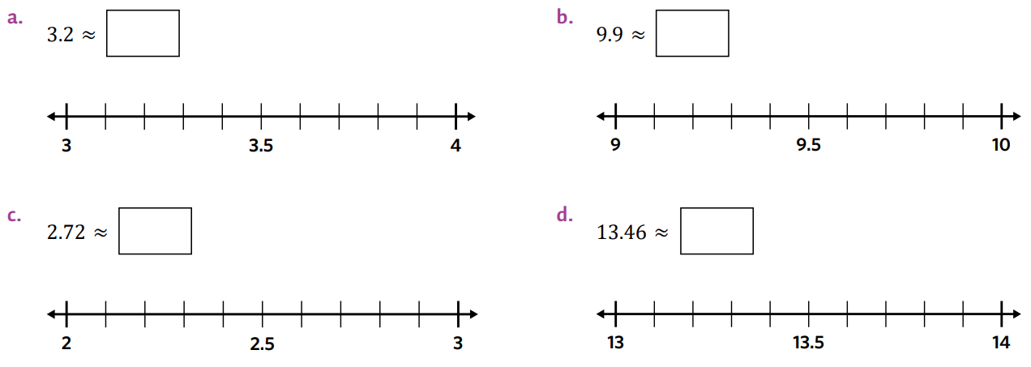  3 | 10
3 | 13
- Use the number line to round each number to 1 decimal place
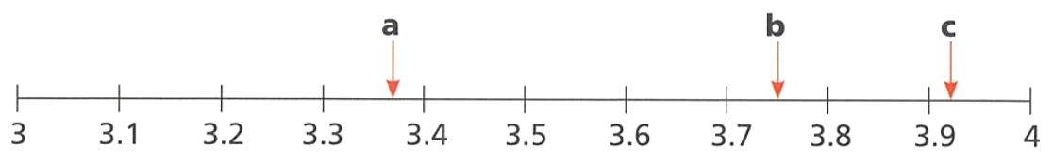

A: 3.4
B: 3.8
C: 3.9
- Use the number line to round each number to 2 decimal places.
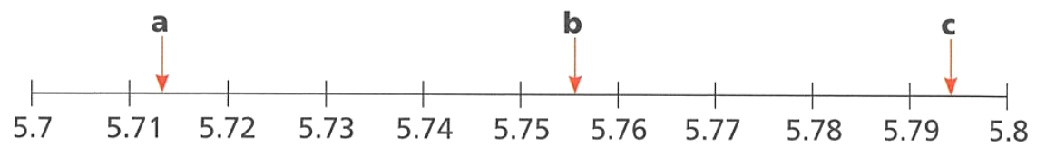

A: 5.71
B: 5.76
C: 5.79

Rounding using the Critical Digit Method

- The Critical Digit Method for Rounding
- Draw a “cut” after the required place value.
- Circle the critical digit right after the cut.
- Decide to round up or down.
  - If critical digit is less than 5, round down.
  - If critical digit is 5 or more, round up.
- Round.
  - rounding down: Remove digits after the cut.
  - rounding up: Add 1 to digit before the cut, then remove digits after the cut.

- Example Round decimals to a place value
Round 22.53486 to the nearest hundredth.  1. Draw cut 2 2 . 5 3 4 8 6  2. Critical digit 2 2 . 5 3 4 8 6  3. Decide Round down  4. Round 2 2 . 5 3  $$22.53486≈22.53$$ | We draw a cut …………… the required place value.  The critical digit is immediately to the ………… of the cut.  When the critical digit is ……… or less, we round down

- Guided Practice
- Round 0.954 to the nearest whole.  $$2 . 9 5 4$$ | - Round 3.276 to the nearest hundredth.  $$3 . 2 7 6$$
- Round 9.871 to the nearest tenth.  $$9 . 8 7 1$$ | - Round 14.2129 to the nearest hundredth.  $$1 4 . 2 1 2 9$$
- Round 8.991 to the nearest tenth. | - Round 1.34294 to the nearest thousandth.

- Decimal Places
Each digit to the right of the decimal point is called a decimal place.

17.854

1st 2nd 3rd
decimal place

- Example Round decimals to a decimal place
Round 246.78 to one decimal place.  1. Draw cut 2 4 6 . 7 8  2. Critical digit 2 4 6 . 7 8  3. Decide Round up  4. Round 2 4 6 . 8  $246.78≈246.8$ | The first decimal place is the ………ths place value.  When the critical digit is ……… or more, we round up.

- Guided Practice
- Round 5.5323 to one decimal place.  $$5 . 5 3 2 3$$ | - Round 3.276 to two decimal places.  $$3 . 2 7 6$$
- Round 9.8742 to two decimal places. | - Round 12.895 to two decimal places.
- Round 81.6814 to two decimal places. | - Round 241.9026343 to one decimal place.

- Key Ideas
- For decimals, you can round to a place value or to a d……………… p…………………
- If the digit to the right of the rounding place is …… or more, round up. If it is …… or less, round down.

Foundation
- State the critical digit in each of the following numbers and decide whether to round up or down.
Question | Critical digit | Round up/down
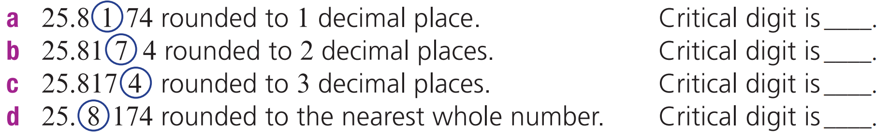 | 1 | Down
 | 7 | Up
 | 4 | Down
 | 8 | Up

- Round each of the following to the nearest whole number.
Draw a line where the number must be cut, circle the critical digit, then round.
a 2 7 . 6 1 2  28 | b 9 . 4 5 8  9 | c 1 2 . 2 9 9  12 | d 1 2 3 . 7 2  124
e 2 2 . 2 6  22 | f 1 1 7 . 5 5 5  118 | g 2 . 6 1 3 2  3 | h 1 0 . 7 5 3 2  11

- Round each of the following amounts to the nearest dollar.
a $12.85  $13 | b $30.50  $31 | c $7.10  $7 | d $1566.80  $1567
e $120.45  $120 | f $9.55  $10 | g $1.39  $1 | h $36.19  $36

- The following decimals need to be rounded to 2 decimal places.
a 1 2 . 6 4 | 5 3  12.65 | b 4 . 8 1 9 3 2  4.82 | c 1 5 7 . 2 8 1  157.28 | d 4 6 5 . 3 8 4 1  465.38
e 0 . 0 6 0 3 1  0.06 | f 2 0 3 . 5 7 9 1  203.58 | g 6 6 . 6 6 6 6  66.67 | h 7 . 9 9 5 1 2 3  8.00

- Round each of the following to 1 decimal place.
a 1 4 . 8 2  14.8 | b 7 . 3 8  7.4 | c 1 5 . 6 2  15.6 | d 0 . 8 7  0.9
e 6 . 8 5  6.9 | f 9 . 9 4  9.9 | g 5 5 . 5 5  55.6 | h 7 . 9 8  8.0
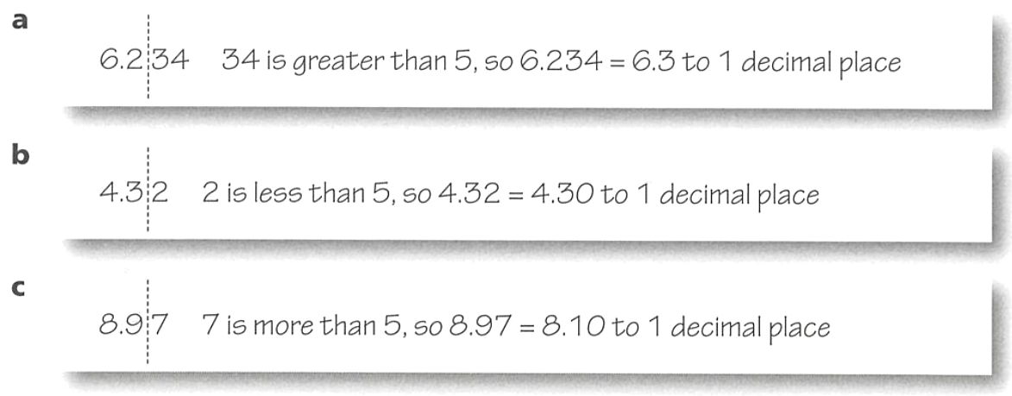
- Explain the mistakes that these students have made, and give the correct answers.

We only look at the digit immediately after the cut; 6.2

When we round down we don’t change the digit before the cut; 4.3

When we round up from 9, it becomes 10, which we carry over to the next place value; 9.0

- Complete the table.
Number | Rounded to 1 d.p. | Rounded to 2 d.p. | Rounded to 3 d.p.
5.6 | 5.6 | 5.60 | 5.600
7.5 | 7.5 | 7.50 | 7.500
1.23 | 1.2 | 1.23 | 1.230
0.152 | 0.2 | 0.15 | 0.152
1.49 | 1.5 | 1.49 | 1.490
0.152 | 0.2 | 0.15 | 0.152
1.5015 | 1.5 | 1.50 | 1.502
1.2753 | 1.3 | 1.28 | 1.275
0.1204 | 0.1 | 0.12 | 0.120
2.3428 | 2.3 | 2.34 | 2.343
12.5007 | 12.5 | 12.50 | 12.501
1.6043 | 1.6 | 1.60 | 1.604
9.9899 | 10.0 | 9.99 | 9.990

Development
- Round these decimals as specified.
- 0.27  to the nearest tenth  0.3 | - 125.91247  to the nearest tenth  125.9 | - 321.4891  to the nearest hundredth  321.49
- 987.7983  to the nearest hundredth  987.80 | - 0.73  to 1 decimal place  0.7 | - 0.67321  to 3 decimal places  0.637
- 3.982178  to 4 decimal places  3.9822 | - 2.987  to 1 decimal place  3.0 | - 3.32913  to the nearest hundredth  3.33
- 19.9267  to the nearest tenth  19.9 | - 0.2985  to 1 decimal place  0.3 | - 0.2714  to 2 decimal places  0.27

- Jamie goes to buy a watermelon. The clerk gives Jamie a watermelon that weighs 10.26 kg. What is the weight of the watermelon rounded to the nearest 100 g?

10.3 kg
- James is ranked first on his cricket team with a batting average of 99.9387.
Cricket batting averages are usually only calculated to two decimal places.
What is James’ batting average rounded to two decimal places?

99.94
- Samara believes 0.449999 should be rounded up to 0.5, but Cassandra believes it should be rounded down to 0.4. Who is correct, and why?

It should be rounded down to 0.4 as the critical digit in the hundredths place value is less than 5.
- Josh is rounding 9.999 to two decimal places. He writes $9.90$. Explain why he is incorrect.

When we round up from 9, it becomes 10, which we carry over to the next place value. This then causes the next place value to change.
The answer should be 10.00

Mastery
- A common mistake students (even senior students!) make is rounding too early.
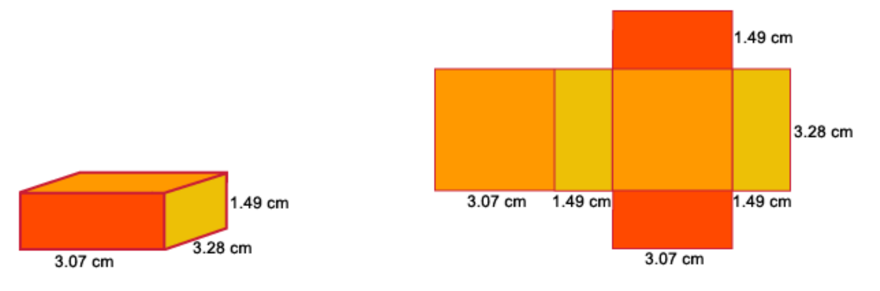
We will find the area of the net of this box.

Rounding after 1 calculation:
Use a calculator to find the exact area of each rectangle, round each answer to 2 decimal places, then add them to find the total area of the net.
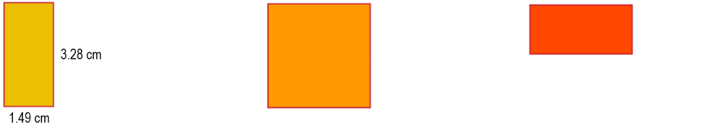  Left and right sides  Area of one side $=3.28×1.49$  $=4.8872$  $≈4.89$ cm²  Area of both sides $≈9.78$ cm² | Top and bottom  Area of top =  $=$  $≈$  Area of top and bottom $≈$ | Front and back  Area of front =  $=$  $≈$  Area of bottom $≈$
Total area of the net = ……………………………………………………………………………………
Rounding at the very end:
Use a calculator to find the exact area of each rectangle. Do not round at any stage.
Left and right sides  Area of one side $=$  $=$  Area of both sides $=$ | Top and bottom  Area of top =  Area of top and bottom = | Front and back  Area of front =  Area of bottom =
Exact total area of the net = ……………………………………………………………………………
Was there a difference between the two methods? ………………………………………………

Terminating and Recurring Decimals

- Terminating and Recurring Decimals
Terminating decimals end: 0.25
Recurring decimals repeat forever: 0.33333333333333333333333333333…
Recurring digits are shown as:
- a dot for a single recurring digit. $0.666666… = 0.\dot{6}$
- a bar for many recurring digits. $0.686868… = 0.\overline{68}$

- Express recurring decimals using dot or bar notation
Express these recurring decimals using the appropriate notation
- 0.555555555555… | - 0.57777777777777… | - 0.57575757575757…
- 0.5959595959595… | - 0.8214821482148214… | - 0.109421094210942…
Use a calculator to express these as decimals using the appropriate notation.
- $\frac{1}{3}$ | - $\frac{2}{3}$ | - $\frac{2}{7}$
- $\frac{5}{6}$ | - $\frac{2}{15}$ | - $\frac{18}{55}$

Foundation
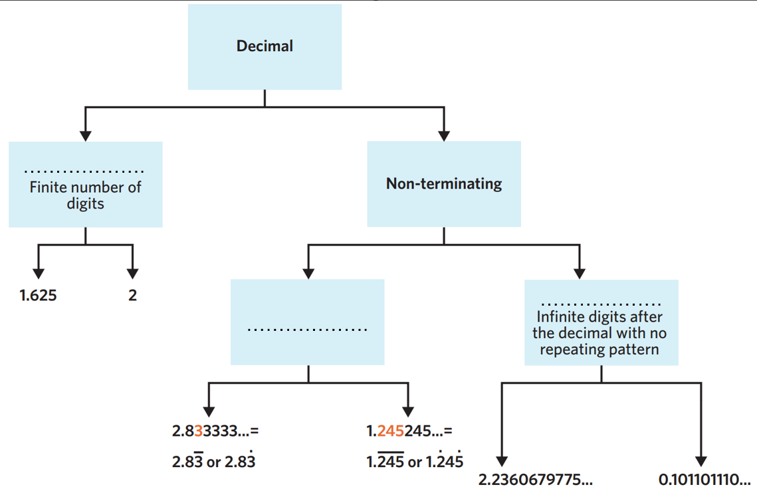
- Fill in the missing words in the diagram.

From left to right: Terminating, Recurring, Non-Recurring
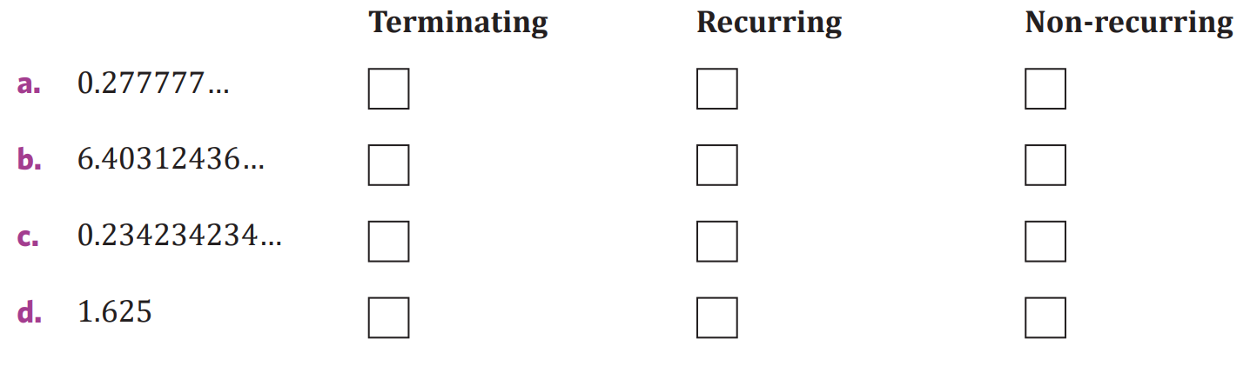
- Classify these decimals as terminating, recurring, or non-recurring

recurring

non-recurring

recurring

terminating

- Classify these decimals as terminating or recurring.
- $0.5$  t | - $0.555555555…$  r | - $0.\dot{5}$  r | - $0.5555555555…$  r
- $0.85$  t | - $0.\overline{85}$  r | - $0.8585858585…$  r | - $0.8585858585$  t
- $0.\overline{76}$  r | - $0.\overline{325}$  r | - $0.1555555555…$  r | - $0.00\overline{291}$  r
- Write the following recurring decimals using the appropriate notation.
- 0.777777777…  $$0.\dot{7}$$ | - 0.355555555…  $$0.3\dot{5}$$ | - 0.28282828…  $$0.\overline{28}$$
- 0.325325325…  $$0.\overline{325}$$ | - 0.678678678…  $$0.\overline{678}$$ | - 1.444444444…  $$1.\dot{4}$$
- 6.922222222…  $$6.9\dot{2}$$ | - 0.033333333…  $$0.0\dot{3}$$ | - 0.9090909090…  $$0.\overline{90}$$
- 0.536666666…  $$0.53\dot{6}$$ | - 3.217777777…  $$3.21\dot{7}$$ | - 8.1818181818…  $$8.\overline{18}$$

  - Use a calculator to convert $\frac{1}{3}$ to a recurring decimal and write using the correct notation.
$$0.\dot{3}$$
  - Use a calculator to convert $\frac{2}{3}$ to a recurring decimal.
Explain why the calculator is not entirely correct.

The calculator says 0.6666666667, it has rounded the answer when it ran out of digits.
  - What would $1\frac{2}{3}$ be as a decimal?

$$1.\dot{6}$$
  - What would $\frac{7}{3}$ be as a decimal?

$$2.\dot{3}$$

- Use a calculator to determine whether these fractions represent terminating or recurring decimals. If they are recurring decimal, write using the correct notation.
- $\frac{4}{3}$  $$1.\dot{3}$$ | - $\frac{3}{3}$  1 | - $\frac{1}{6}$  $$0.1\dot{6}$$ | - $\frac{2}{6}$  $$0.\dot{3}$$
- $\frac{11}{30}$  $$0.3\dot{6}$$ | - $\frac{18}{15}$  1.2 | - $\frac{5}{9}$  $$0.\dot{5}$$ | - $\frac{7}{45}$  $$0.1\dot{5}$$
- $\frac{7}{8}$  0.875 | - $\frac{4}{9}$  $$0.\dot{4}$$ | - $1\frac{5}{12}$  $$1.41\dot{6}$$ | - $1\frac{2}{3}$  $$1.\dot{6}$$
- $\frac{11}{18}$  $$0.6\dot{1}$$ | - $\frac{22}{33}$  $$0.\dot{6}$$ | - $1\frac{13}{22}$  $$0.59\overline{09}$$ | - $\frac{11}{24}$  $$0.458\dot{3}$$

- The number $π$ (pi) can be represented as a never-ending decimal. The first 100 digits of pi are:
3.141 592 653 589 793 238 462 643 383 279 502 884 197 169 399 375 105 820 974 944 592
307 816 406 286 208 998 628 034 825 342 117 067 …
Would you classify $π$ as a terminating or recurring decimal, or neither? Explain your reasoning.

Neither. It is a non-terminating, non-recurring decimal.

